Module 03 – Production Modeling

Exploratory Data Analysis

*In this section, you should perform some data analysis on the data provided to you. Please format your findings in a visually pleasing way and please be sure to include these cuts:*

* *Make a table of average demand, production capacity, and costs for each quarter, are there differences between quarters?*
* *Since we have temporal data (i.e. year and quarter), see if you can make a yearly and/or quarterly chart showing these metrics over time.*

Model Formulation

*Write the formulation of the model into here prior to implementing it in your Excel model. Be explicit with the definition of the decision variables, objective function, and constraints*

Decision variables – Units produced

Objective function: =SUM(quarterly production cost + Q. Carrying Cost)

Constraints: Units Produced <= Maximum Production (capacity)

Ending Inventory >= Minimum Inventory (safety stock)

Model Optimized for Cost Reduction

*Implement your formulation into Excel and be sure to make it neat. This section should include:*

* *A screenshot of your optimized final model (formatted nicely, of course)*
* *A text explanation of what your model is recommending*

Model with Stipulation

*Please copy the tab of your original model before continuing with the next part to avoid messing up your original solution. If we remove the production capacity constraint from the model & we removed the carrying cost, what do you think will happen? Try it out and see if it matches your expectation. Try to explain what is happening and talk a bit about fallbacks of models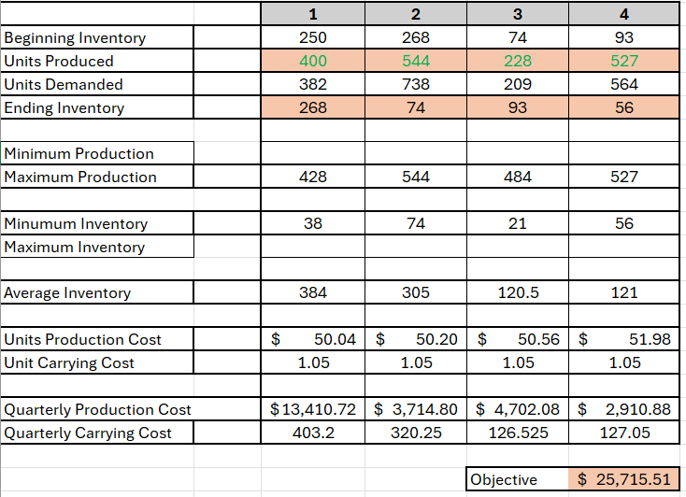.*

My model is recommending to produce 400 units in Q1, 544 in Q2, 228 in Q3, and 527 in Q4 and carry the inventory from one quarter into the next, resulting in a total cost of $25,715.51